Online Purchase Behaviour Classification

Project Id: AIML - 21

Name : Prakash Chandra Pandey
Class Roll Number:61
University Roll Number : 2028799
Section and Group: Q(G2)

Name : Harsh Rastogi
Class Roll Number:46
University Roll Number : 2028722
Section and Group: Q(G2)

Name : Ayush Pundir
Class Roll Number:43
University Roll Number : 2028686
Section and Group: Q(G2)

TABLE OF CONTENTS
- Problem Description 3
  - Dataset Description 3
  - Flow diagram 4
- Modules for Project Implementation…………………..…………………………5
  - Modules Used 5
  - Platform Used 6
- Machine Learning model/ Searching Technique used 7
- Evaluation metrics used 8
- Results and Visualizations 9
- Conclusion and Future Scope 11
- References 12

- Problem Description
In today’s rapidly growing e-commerce industry, understanding customer behavior has become essential for improving sales, enhancing user experience, and optimizing marketing strategies. Online platforms generate a large amount of user interaction data, such as browsing patterns, time spent on pages, and product engagement. However, analyzing this data manually to predict whether a user will make a purchase is complex and inefficient.
The problem addressed in this project is to develop a machine learning-based system that can accurately predict whether a user will complete an online purchase based on their session behavior and interaction data. The dataset includes various attributes such as page visits, duration of browsing, bounce rates, exit rates, and user type, all of which influence purchasing decisions.
By applying classification algorithms like Logistic Regression, K-Nearest Neighbors (KNN), Support Vector Machine (SVM), and Decision Tree, the system learns patterns from historical data and classifies users into two categories: those likely to make a purchase and those who are not. This prediction can help businesses identify potential customers in real-time and take proactive actions such as targeted advertisements, personalized recommendations, and promotional offers.
The proposed system aims to improve decision-making for e-commerce platforms by providing accurate predictions and valuable insights into customer behavior. It reduces reliance on manual analysis and enhances the efficiency of marketing strategies. Overall, this project demonstrates how machine learning can be effectively used to solve real-world business problems in the domain of online retail.

  - Dataset Description
The dataset used in this project is “Online Purchase Prediction Dataset”, which contains real user session data collected from an e-commerce website. Each row in the dataset represents a single user session, and the features describe the user’s browsing behavior, interaction with web pages, and session details.
The dataset is structured and suitable for binary classification, where the objective is to predict whether a user will complete a purchase or not.
Source: Synthetic dataset created to simulate real-world company data.
Target Variable: Purchase.
Primary Purpose: To build a machine learning classification model that analyzes user session data and predicts purchase intention, helping e-commerce platforms improve customer targeting and decision-making.

Features Details :

1. Browsing_Time
- Total time spent by the user browsing the website
- Higher browsing time may indicate higher interest in products

2. Clicks
- Total number of clicks made during the session
- Reflects user engagement level
3. Product_Views
- Number of product pages viewed by the user
- Higher values indicate stronger product interest

4. Cart_Additions
- Number of times products were added to the cart
- Strong indicator of purchase intent

5. Previous_Purchases
- Number of past purchases made by the user
- Helps identify returning or loyal customers

6. Time_on_Product_Page
- Time spent specifically on product pages
- Longer duration suggests higher buying interest

7. Bounce_Rate
- Indicates how quickly a user leaves the website
- Higher bounce rate → lower engagement

8. Discount_Viewed
- Indicates whether the user viewed discount offers
- Can influence purchasing decisions

9. Purchase (Target Variable)
- Indicates whether the user made a purchase:
  - 1 → Purchase made
  - 0 → No purchase

Final Deployment Features
During the final training phase, a subset of the 4 most impactful features was selected for the production model:
1.Browsing_Time

2.Clicks
3.Product_Views

4.Cart_Additions

  - Flow Diagram

1. Data Collection
The dataset consists of online user session data, including features like browsing time, clicks, product views, and purchase behavior.

2. Data Preprocessing
- Missing values were handled appropriately
- Categorical data (if any) was converted into numerical form
- Relevant features were selected to improve performance

3. Train-Test Split (80:20)
The dataset was divided into training (80%) and testing (20%) data to evaluate model performance on unseen data.

4. Model Training
The following classification models were applied:
- Logistic Regression
- KNN
- SVM
- Decision Tree

5. Predictions
The models were used to predict purchase behaviors

6. Model Evaluation
Models were evaluated using:
- Accuracy
- Precision
- Recall
- F1 Score

7.Final Output
The trained machine learning model predicts the purchase behavior of users in binary form:
- 0 → No Purchase
- 1 → Purchase
For each user session, the model analyzes input features such as browsing time, clicks, product views, and cart additions, and then outputs a prediction indicating whether the user is likely to make a purchase.

2. Modules for Project Implementation

2.1 Modules Used(mention all the inbuilt/ custom modules used and the purpose)
The following inbuilt libraries and modules were used in the implementation of the Online Purchase Behaviour Classification system:

1. Pandas
- Used for data loading, manipulation, and preprocessing
- Helps in handling datasets in tabular format
Purpose:
To read the dataset, clean data, and perform data analysis

2. NumPy
- Used for numerical computations and array operations
Purpose:
To perform mathematical calculations and handle numerical data efficiently

3. Matplotlib
- Used for data visualization
Purpose:
To create graphs and plots for better understanding of model performance

4. Seaborn
- Built on Matplotlib for advanced visualization
Purpose:
To generate heatmaps (confusion matrix) and improve graphical representation

5. Scikit-learn (sklearn)
- Core machine learning library used in the project
Purpose:
To implement machine learning models and evaluation metrics

Submodules Used from Scikit-learn
- model_selection
  - train_test_split()
Splits dataset into training and testing sets
- linear_model
  - LogisticRegression()
Used for classification
- neighbors
  - KNeighborsClassifier()
Used for KNN model
- svm
  - SVC()
Used for Support Vector Machine
- tree
  - DecisionTreeClassifier()
Used for decision tree model
- metrics
  - accuracy_score()
  - precision_score()
  - recall_score()
  - f1_score()
  - classification_report
  - confusion_matrix
  - ConfusionMatrixDisplay
Used to evaluate model performance

2.2 Development Platforms
- Visual Studio Code (VS Code): Used as the Integrated Development Environment (IDE) for writing and debugging the scripts.
- Jupyter Notebooks: Used for interactive development, allowing for the visualization of results and step-by-step execution of the training and deployment pipelines.

3. Machine Learning Model/ Searching Technique Used(Describe each ML model/ searching technique used)

1. Logistic Regression (Selected Model)
Logistic Regression was chosen as the final model due to its high performance, simplicity, and effectiveness in binary classification problems.
- Purpose:
To predict whether a user will make an online purchase based on browsing behavior and session features.
- Mechanism:
It uses a sigmoid function to map input features into probabilities between 0 and 1. The model applies an optimization technique to find the best coefficients that minimize classification error.
- Result:
This model achieved the highest performance with strong accuracy and F1 score, making it the most reliable model for predicting purchase behavior.

2. KNN, SVM, and Decision Tree (Baseline Models)
- K-Nearest Neighbors (KNN):
Used as a distance-based classification model that predicts the class based on the nearest neighbors. It performs well but is slightly less efficient for larger datasets.
- Support Vector Machine (SVM):
Used to create an optimal boundary between purchasing and non-purchasing users. It achieved performance similar to Logistic Regression.
- Decision Tree:
A rule-based model that splits data into branches based on feature values. It is easy to interpret but slightly less accurate compared to other models.

Searching/Optimization Technique
The system employs Sequential Feature Selection (SFS) to optimize the model’s performance.
- Direction: Forward Selection.
- Process: The algorithm starts with an empty set of features and adds one feature at a time—the one that provides the maximum improvement to the model.
- Goal: This technique was used to reduce the original 8 features down to the 4 most impactful features for the final prediction, reducing computational noise and improving model efficiency.

4.Model Evaluation Metrics
To evaluate the performance of the classification models, the following metrics were used:

1. Accuracy
Accuracy measures the overall correctness of the model by calculating the ratio of correctly predicted observations to the total observations.
Accuracy = (TP + TN) / (TP + TN + FP + FN)
Where:
- TP = True Positives
- TN = True Negatives
- FP = False Positives
- FN = False Negatives
Used to evaluate overall model performance.

2. Precision
Precision measures how many of the predicted positive cases are actually correct.
Precision = TP / (TP + FP)​
Important when false positives need to be minimized.

3. Recall (Sensitivity)
Recall measures how many actual positive cases are correctly identified by the model.
Recall = TP / (TP + FN)
Important when missing positive cases is critical.

4. F1 Score
F1 Score is the harmonic mean of Precision and Recall, providing a balance between the two.
F1 Score = 2 * (Precision * Recall) / (Precision + Recall)
Useful when dataset is imbalanced.

5. Results and Visualizations

The performance of different machine learning models was evaluated using accuracy, precision, recall, and F1 score.

Evaluation of all the models
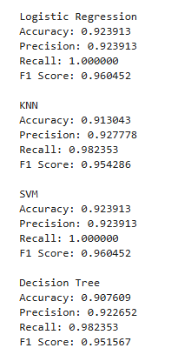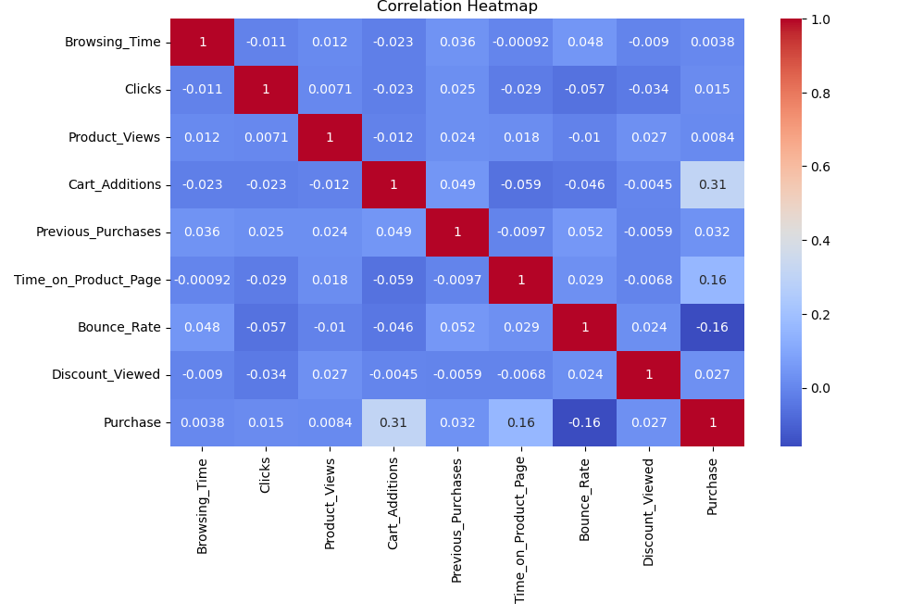

Evaluation of final model

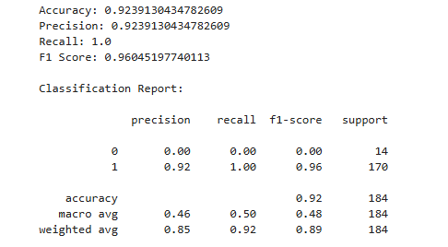

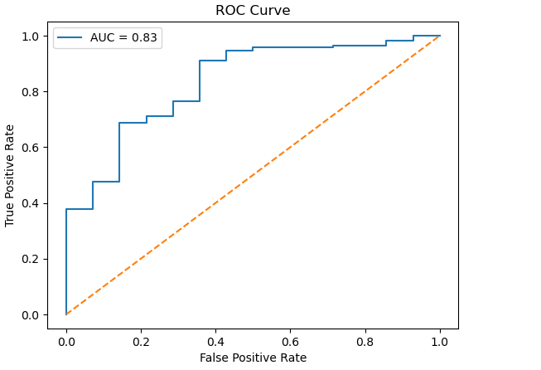

6.Conclusion and Future Scope

Conclusion
In this project, we used Logistic Regression to build a model for classification. We first prepared the data, selected important features, and then trained the model. The model gave good results in terms of accuracy and was able to make correct predictions in most cases.
This project helped in understanding the basics of machine learning, data handling, and how models are evaluated. It also showed how feature selection can improve performance. Overall, the project was successful in achieving its objective.

Future Scope
There are several ways in which this project can be improved in the future:
- We can use more advanced machine learning algorithms to improve accuracy.
- The model can be trained on a larger dataset for better results.
- More features can be added to make predictions more accurate.
- The project can be converted into a real-time application or website.
- Better graphs and visualizations can be added for clear understanding.

7. References:
Books:
- Let Us Python – Yashavant Kanetkar

Online Resources:

  - GeeksforGeeks – https://www.geeksforgeeks.org/
  - TutorialsPoint – https://www.tutorialspoint.com/cprogramming/index.htm
  - Stack Overflow – https://stackoverflow.com
  - https://youtube.com/@sheryiansai
  - Matplotlib Documentation – Used for data visualization and graphs

